Airport Check-in: Sculpture inspired by flight takes wing

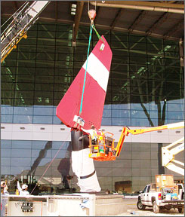
Enlarge | Indianapolis International Airport
'Cardinalis', named after the Indiana state bird, is a 35-foot tall sculpture created by John Van Alstine.

By Roger Yu, USA TODAY
INDIANAPOLIS:
Indianapolis International finished installing the first artwork that will adorn the new $1.1 billion main terminal scheduled to open in October. Cardinalis, named after the state bird, is a 35-foot-tall sculpture featuring an actual wing from an F-14 Tomcat aircraft, a supersonic, twin-engine fighter recently retired by the U.S. Navy.
Created by sculptor John Van Alstine, the piece depicts a red wing that is connected to the earth by a sweeping arch. It symbolizes the "bridging between earth and sky that is the function of airports," an airport statement says.

